**AMERICAN INTERNATIONAL UNIVERSITY–BANGLADESH (AIUB)**

**FACULTY OF SCIENCE & TECHNOLOGY**

**DIGITAL LOGIC AND CIRCUITS LAB**

**Summer 2022-2023**

Section: F

Group Number: 02

**EXPERIMENT NO. 7**

**NAME OF THE EXPERIMENT**

*Implementation of Asynchronous and Synchronous counters using flip-flops*

**Supervised By**

SHAHRIYAR MASUD RIZVI

Faculty of Engineering, AIUB

**Submitted By**:

|  |  |
| --- | --- |
| **Name of the Student** | **ID Number** |
| 1. NOKIBUL ARFIN SIAM | 21-44793-1 |
| 1. AHNAF AHMED | 20-42173-1 |
| 1. SAIFUL ISLAM | 20-42585-1 |
| 1. MAHADI HASAN | 19-39711-1 |
| 1. SHEIKH FAHIM FUAD | 21-44721-1 |

**Introduction:**

The purpose of this experiment is to learn about the counters and their characteristic against interval pulses using flip-flops. Also, we will learn two types of counters Asynchronous and Synchronous counters using the J-K flip flop. If the flip-flops do not receive the same clock signal, then that counter is called as Asynchronous counter. The output of system clock is applied as clock signal only to first flip-flop. The remaining flip-flops receive the clock signal from output of its previous stage flip-flop. If all the flip-flops receive the same clock signal, then that counter is called as Synchronous counter.

**Theory and Methodology:**

**Asynchronous Counter:** In a three-bit asynchronous counter, the external counter is connected to the clock input of the first flip-flop (FF0) only. By getting the Q output of FF0, then FF1 will be triggered. Because of the propagation delay through the flip-flop, the transition between the input clock pulse and the transition of the Q output of FF0 can never occur at the same time.

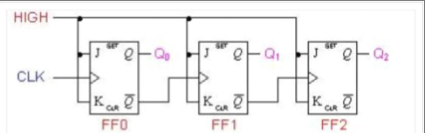

**Figure-2:** 3-bit Asynchronous Counter

**Synchronous Counter:** In a three-bit synchronous counter,the clock inputs of all the flip-flops are connected with each other. By this, all the flip-flops change their state parallelly. The advantage of this counter is that there is no cumulative time delay because all flip-flops are triggered in parallel.

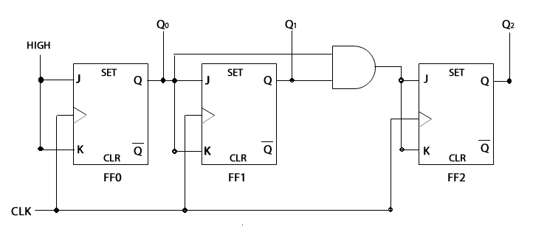

**Figure-3:** 3-bit Synchronous Counter

**Apparatus:**

* IC 74LS76 (JK Flip Flop)
* IC 7408 (AND Gate)
* LED Lamps or Display
* Trainer Board
* Oscilloscope
* Connecting Wires

**Hardware implementation**

**Asynchronous Counter:**

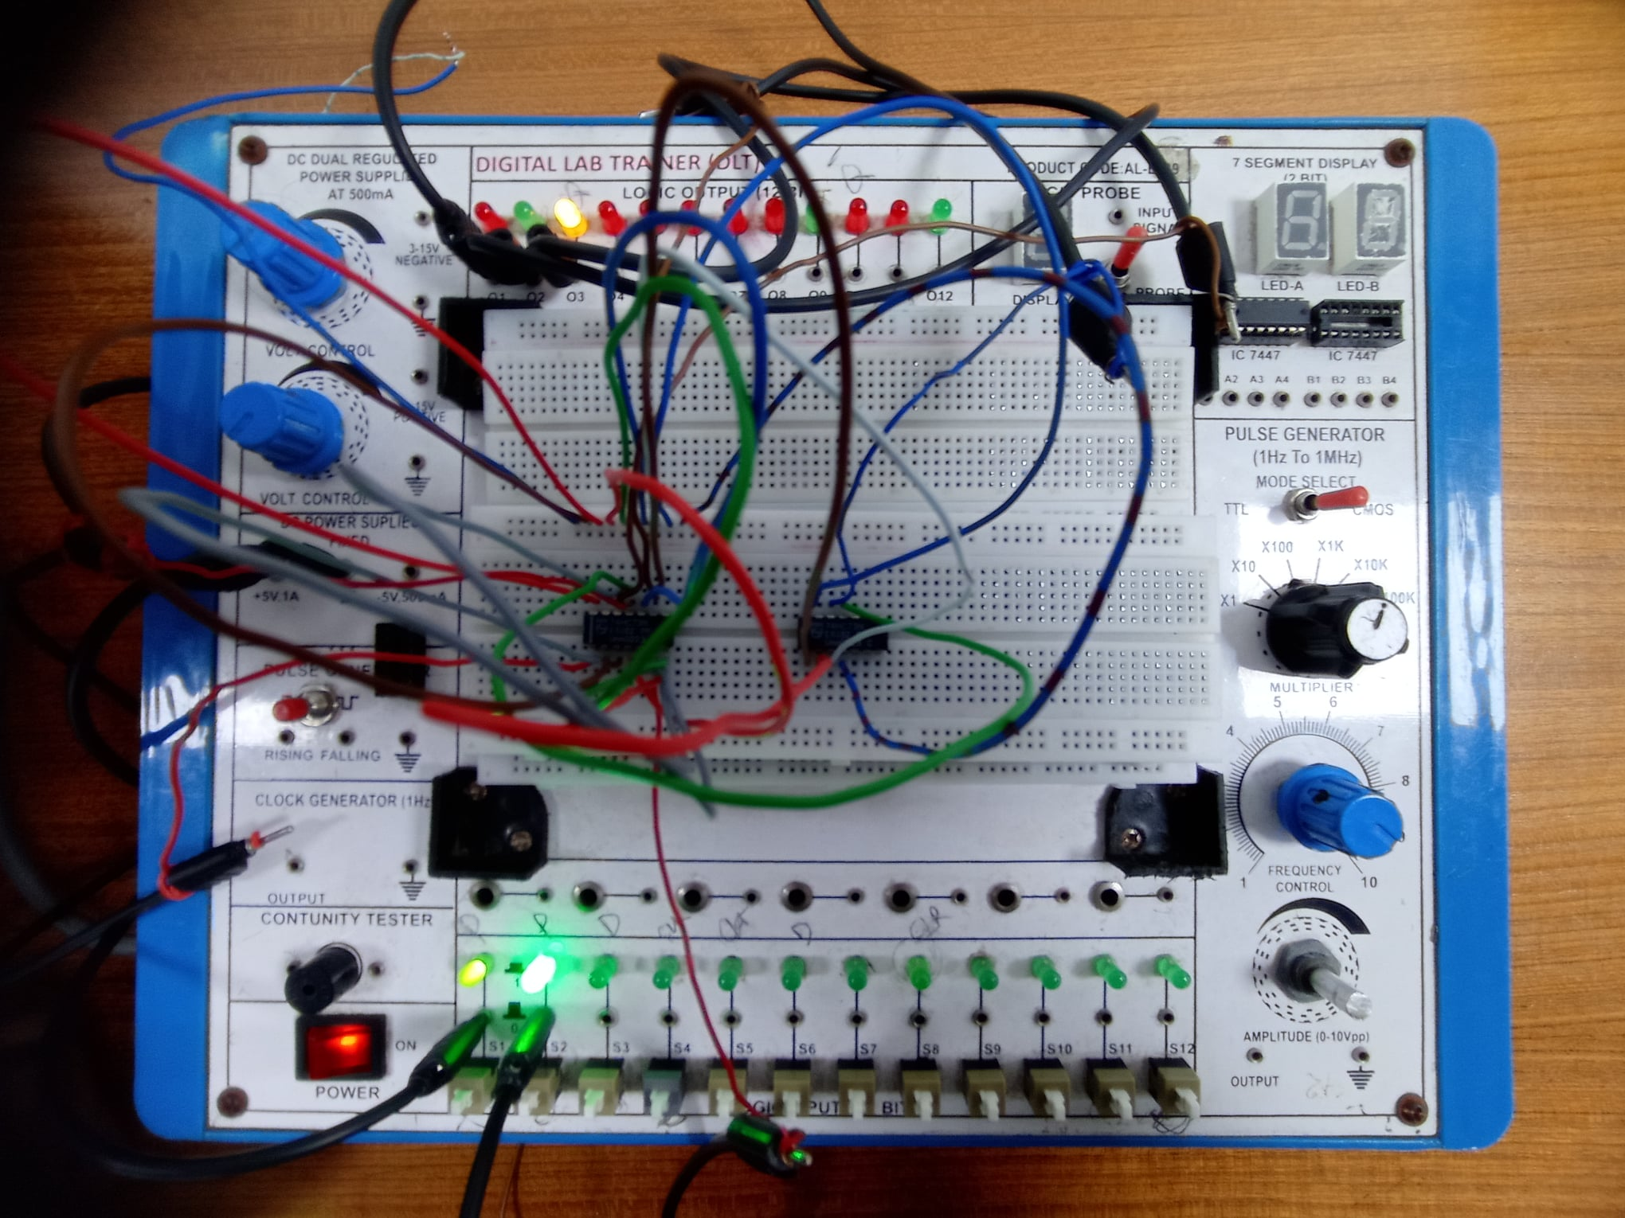

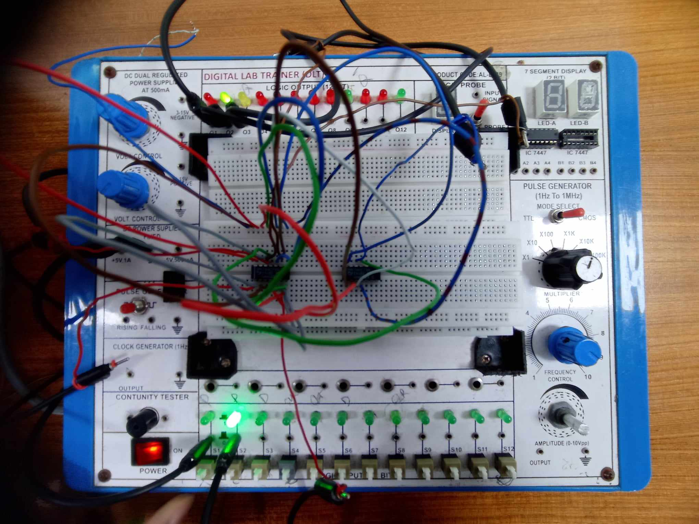

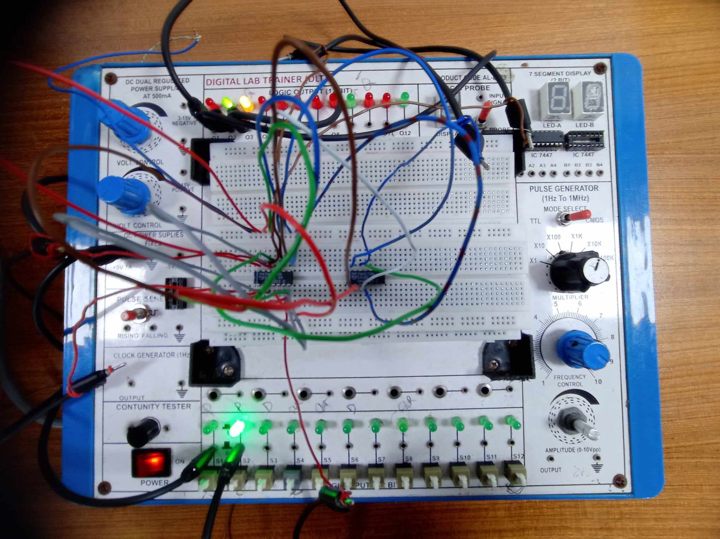

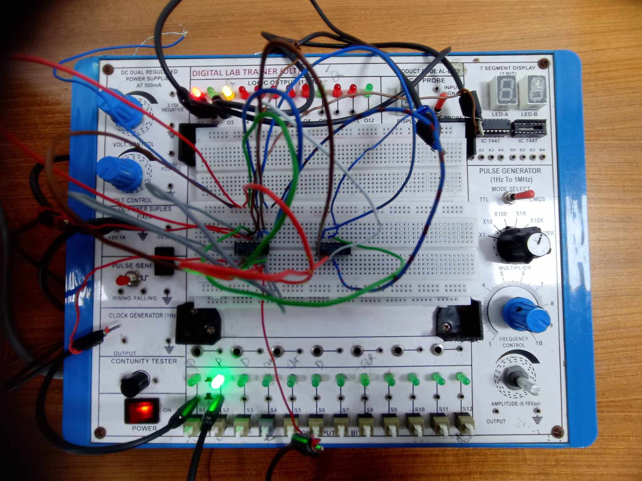

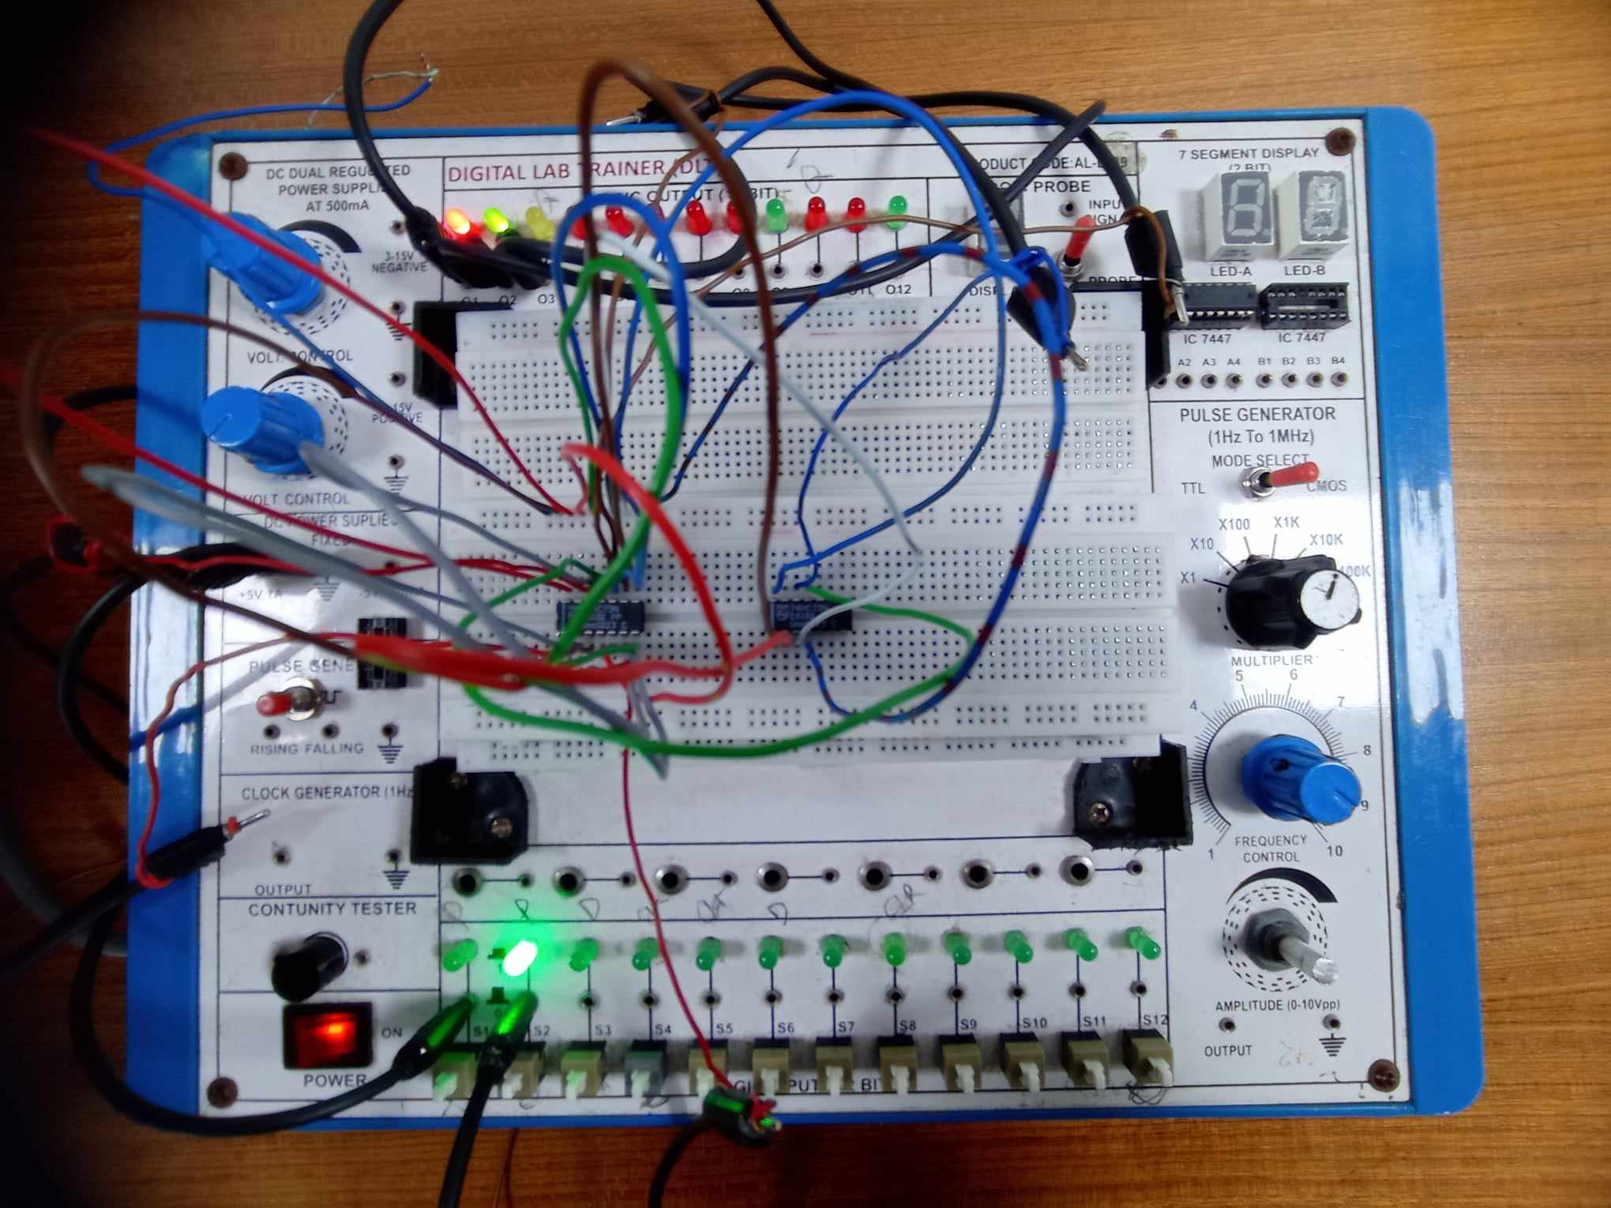

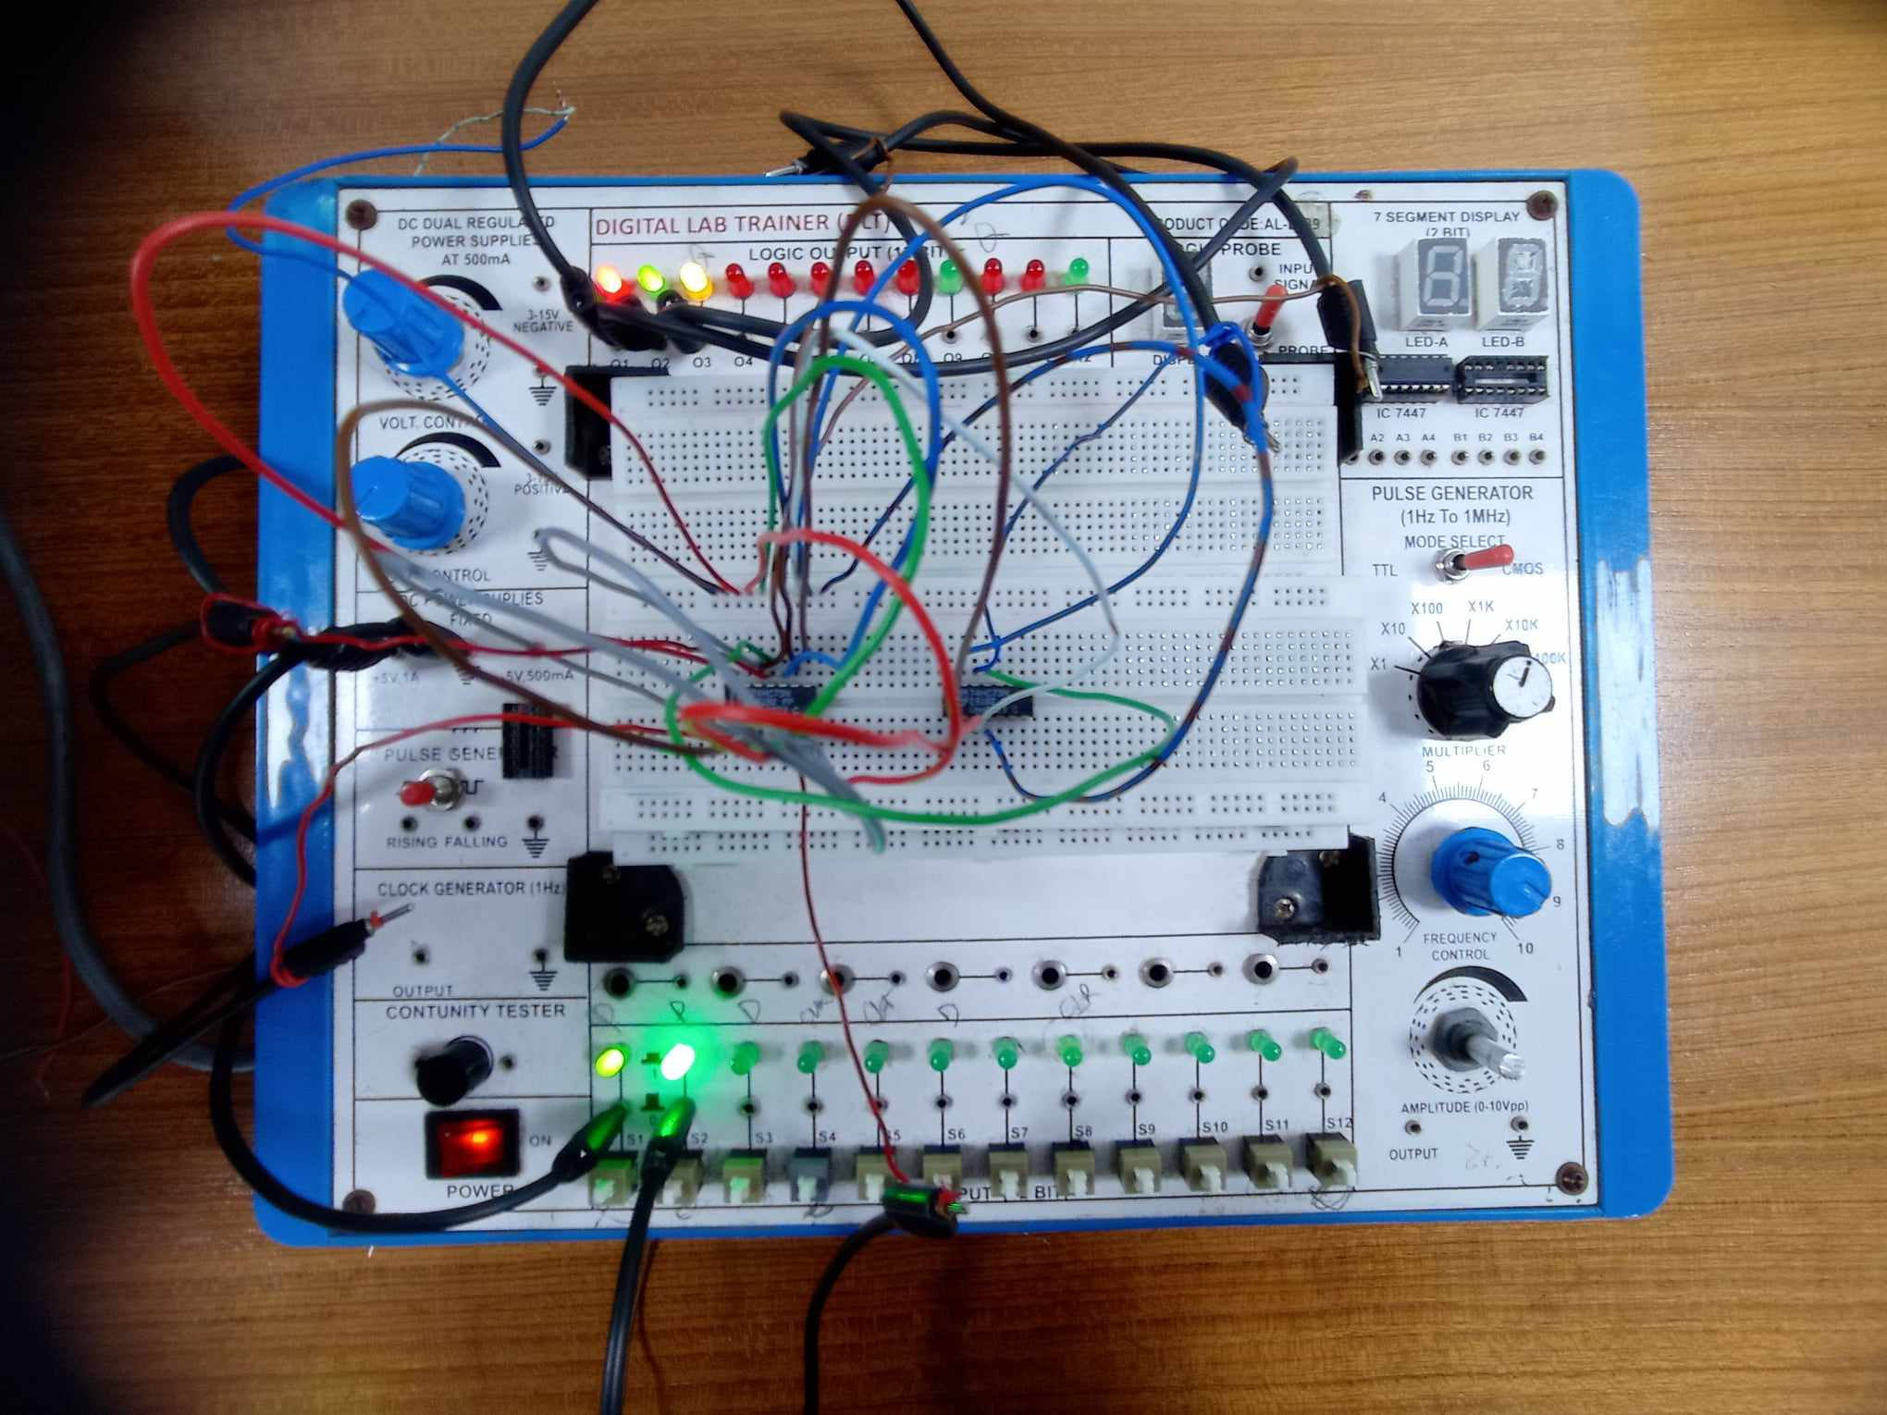

**Synchronous Counter:**

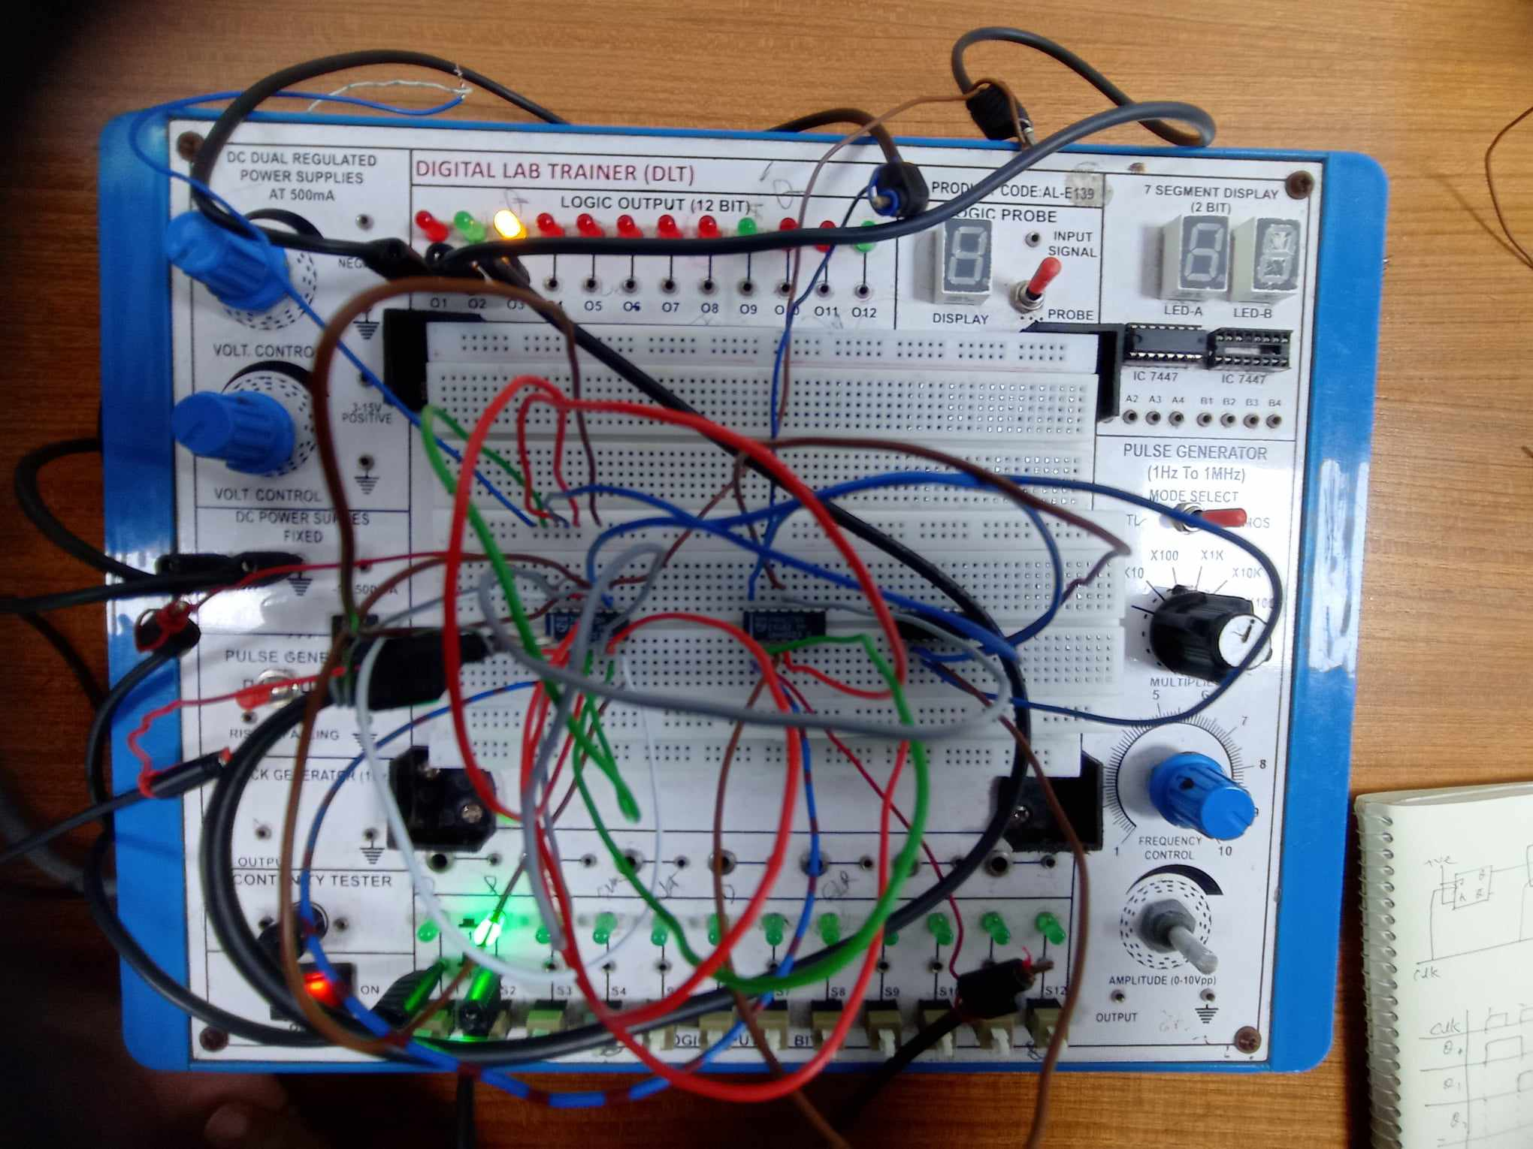

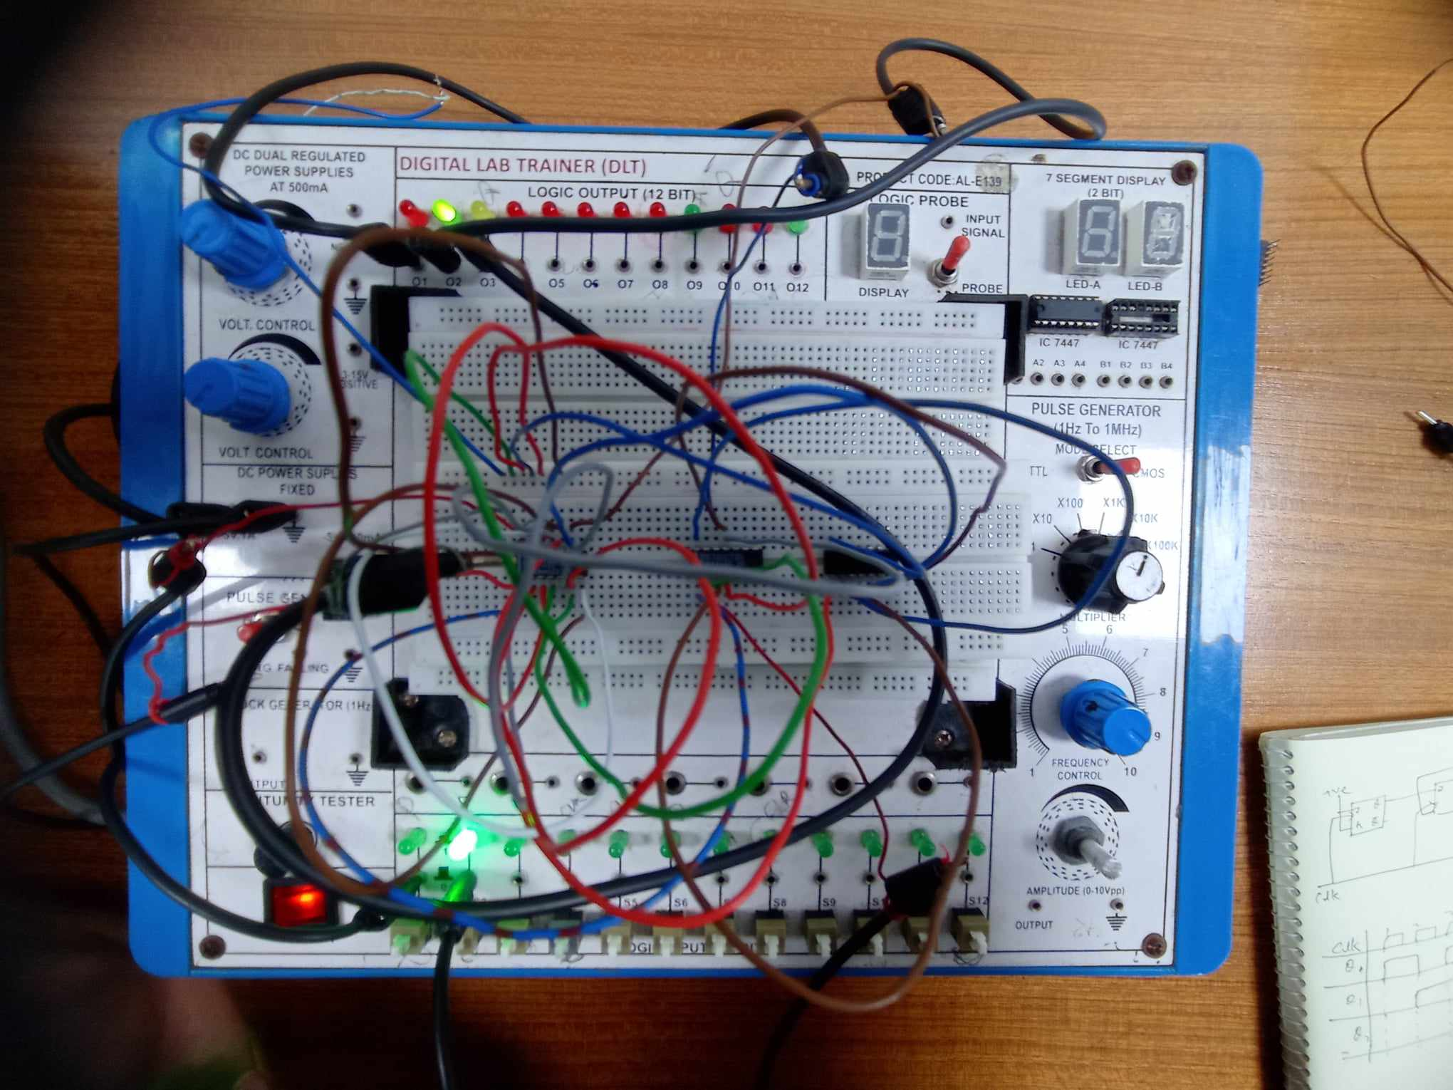

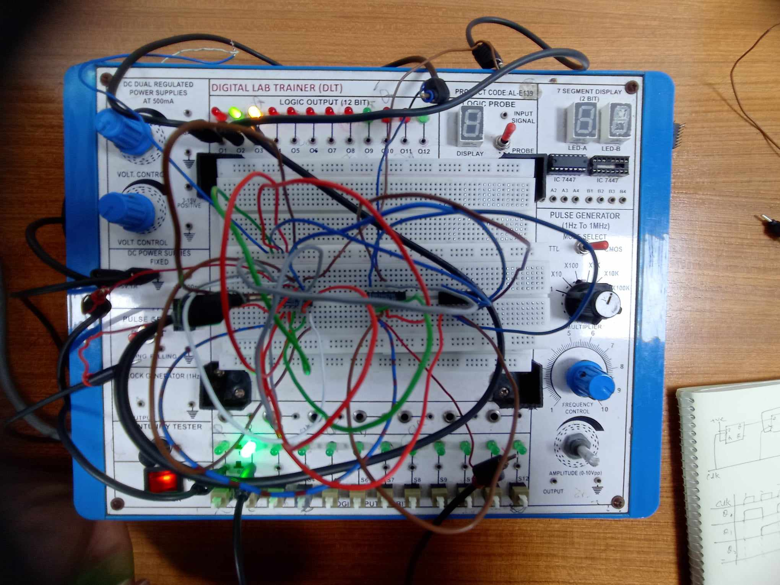

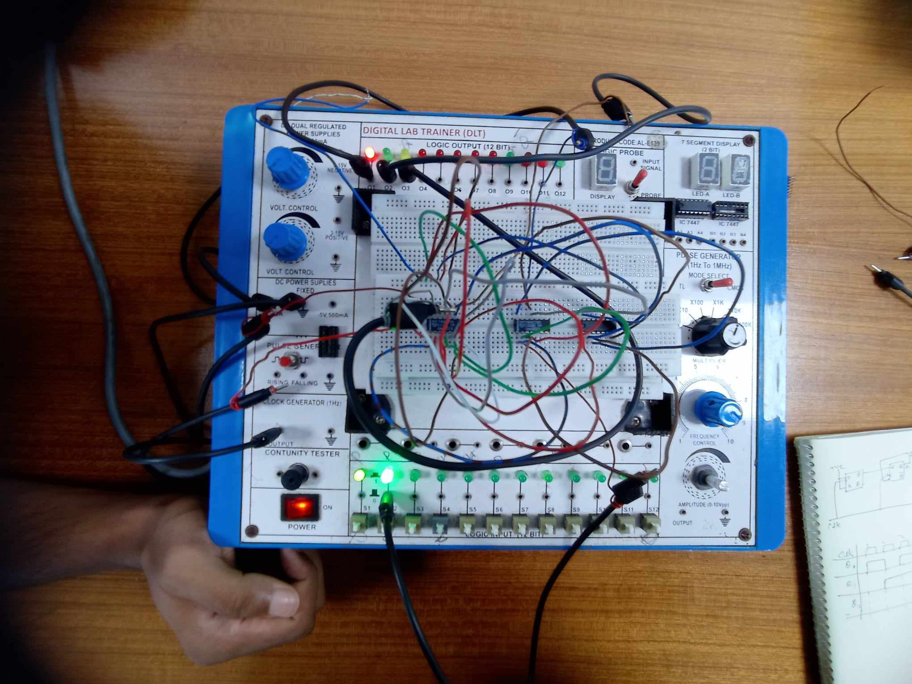

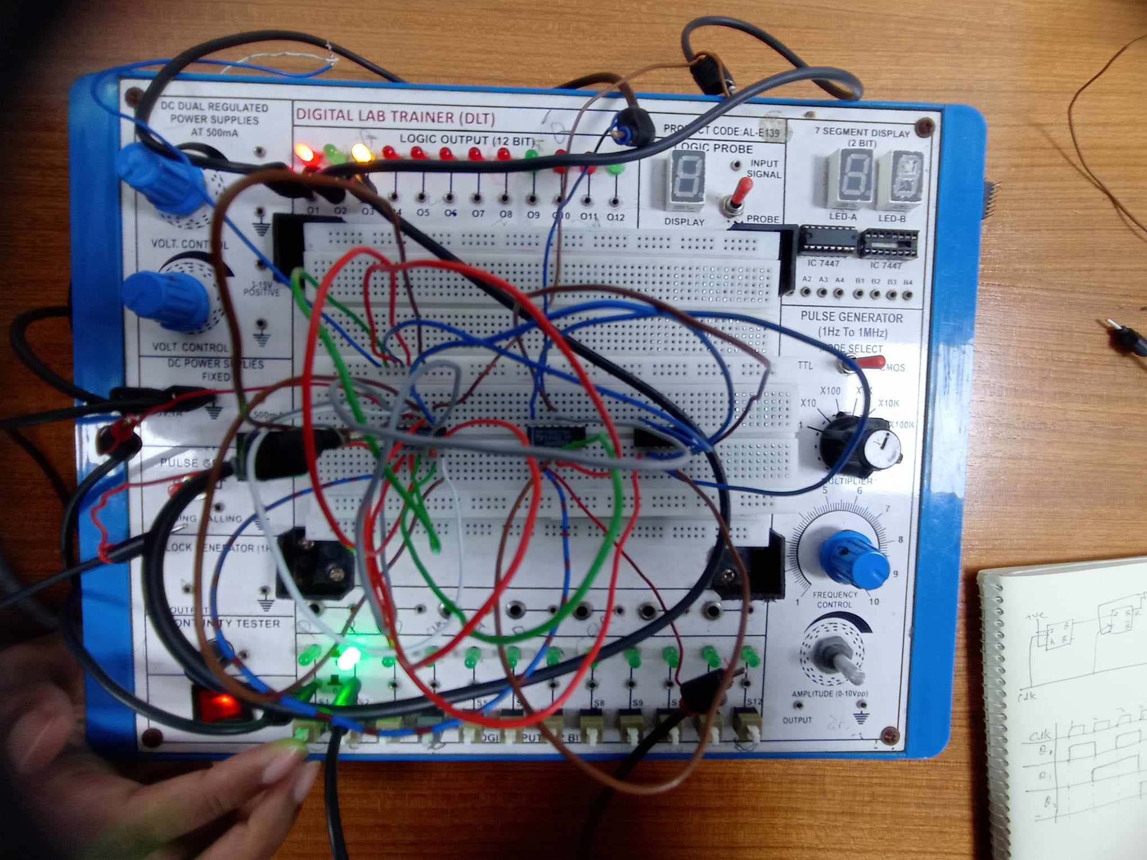

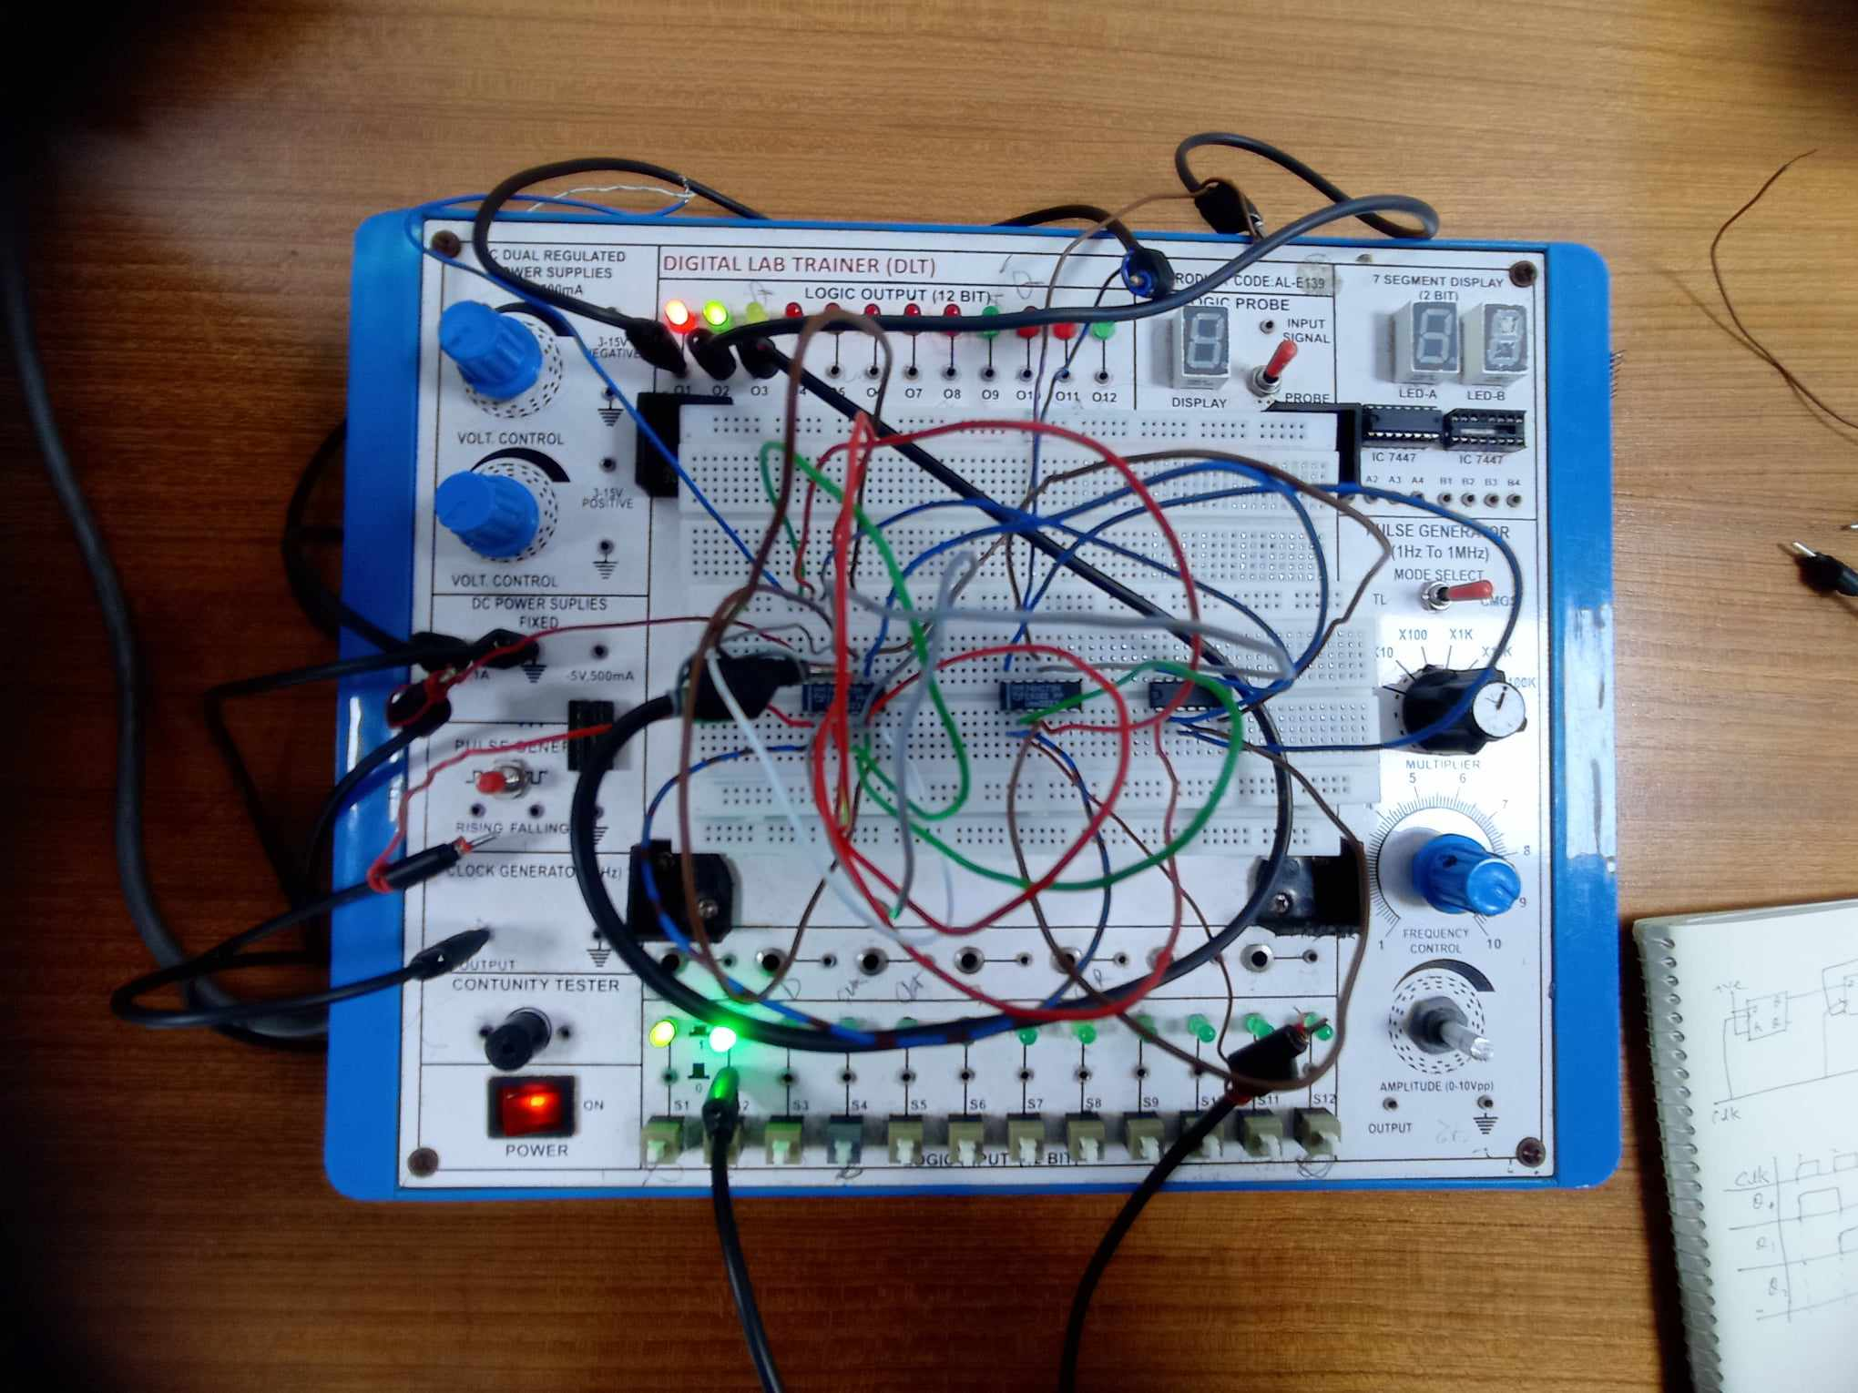

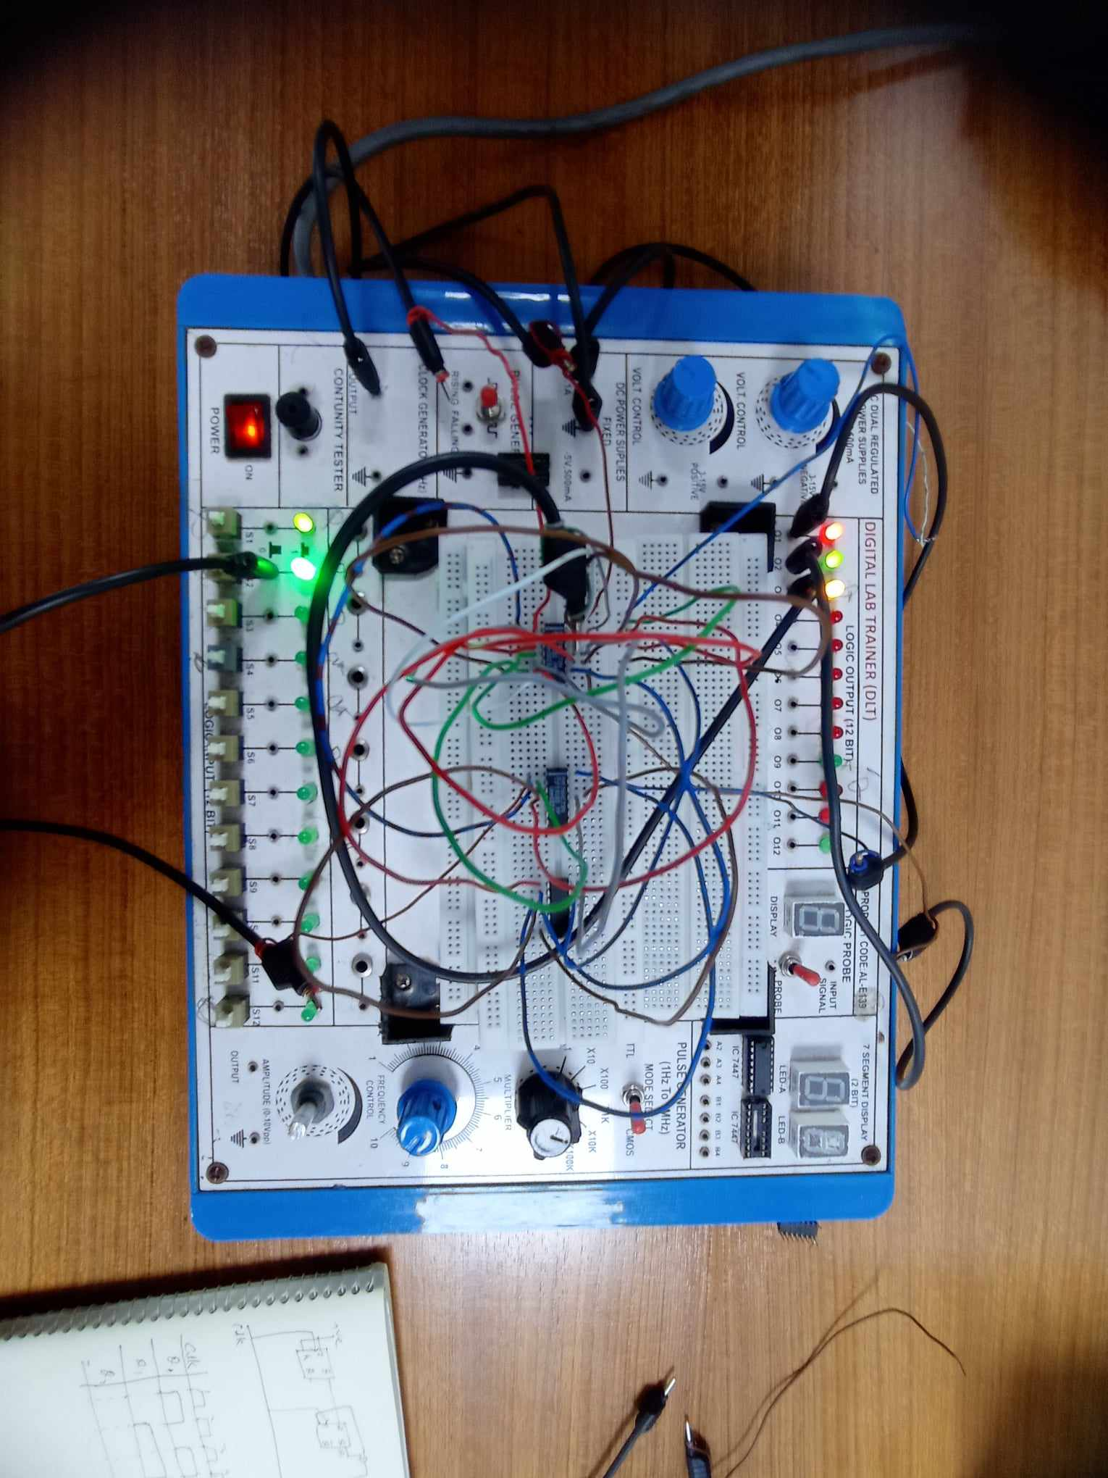

**Simulation**

**3- bit synchronous up counter:**

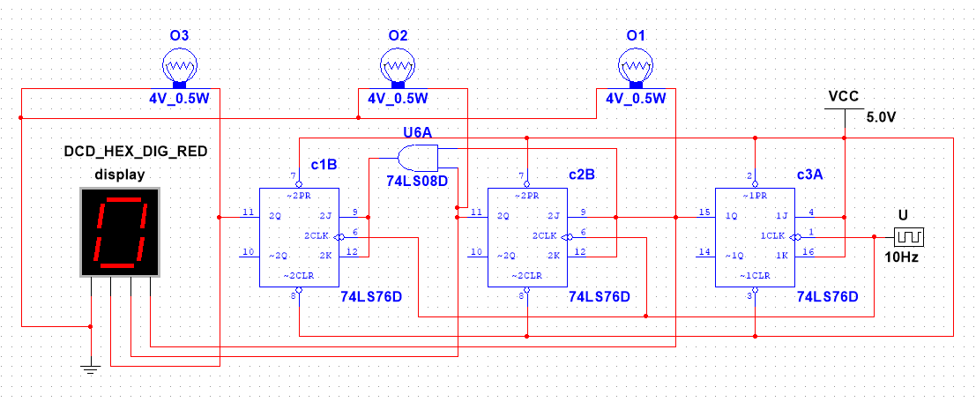

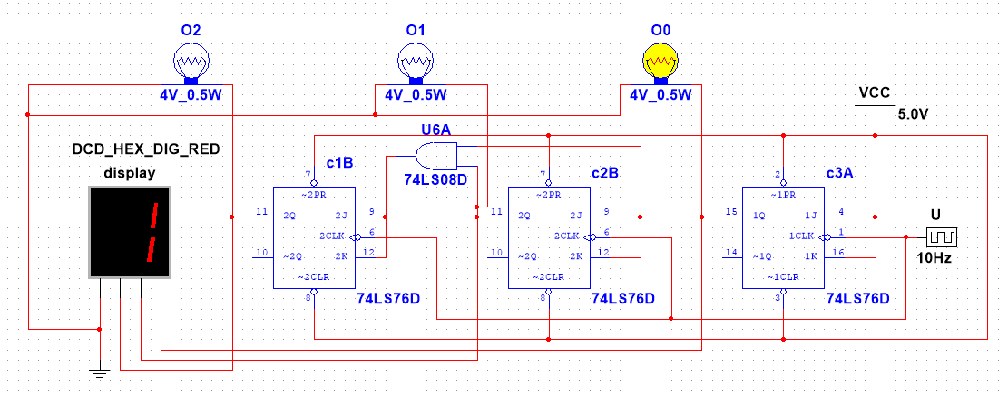

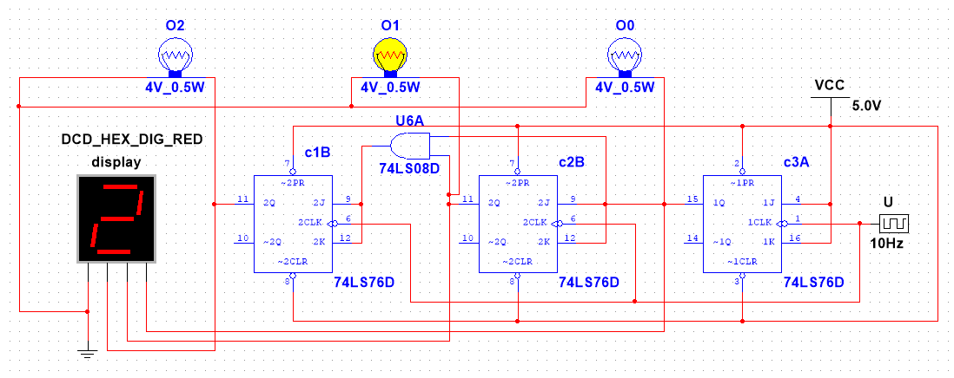

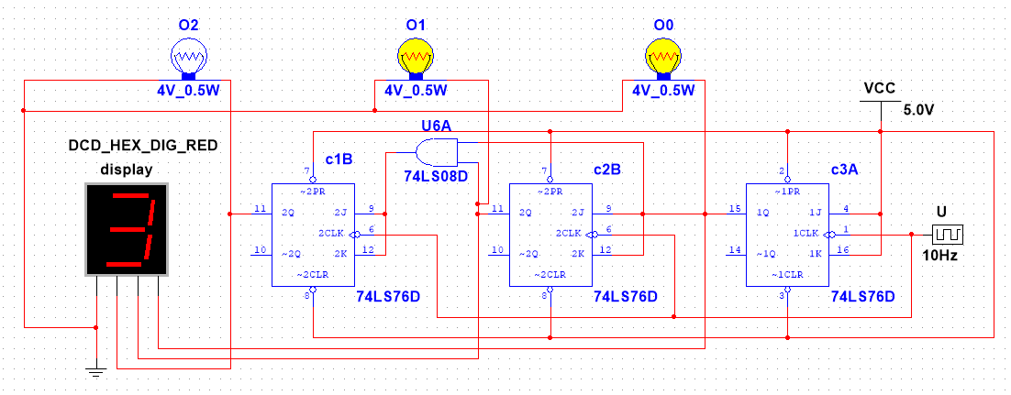

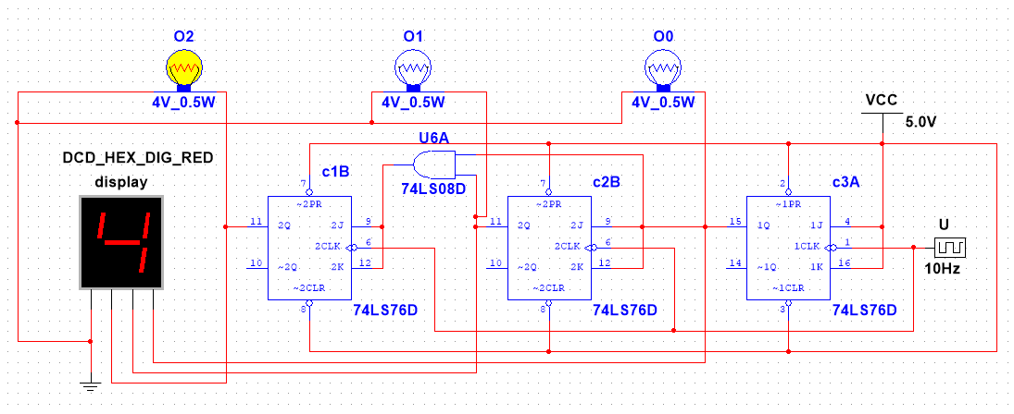

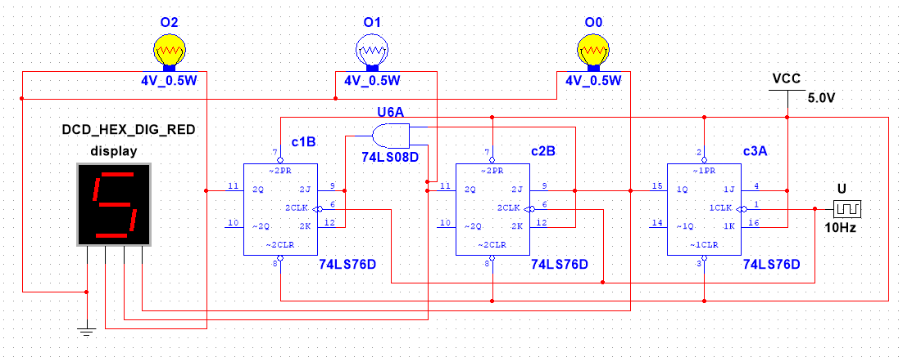

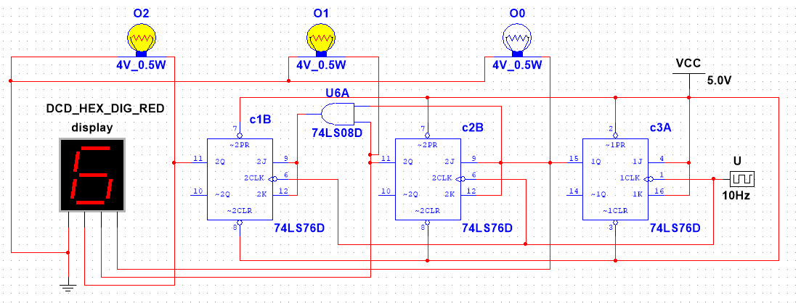

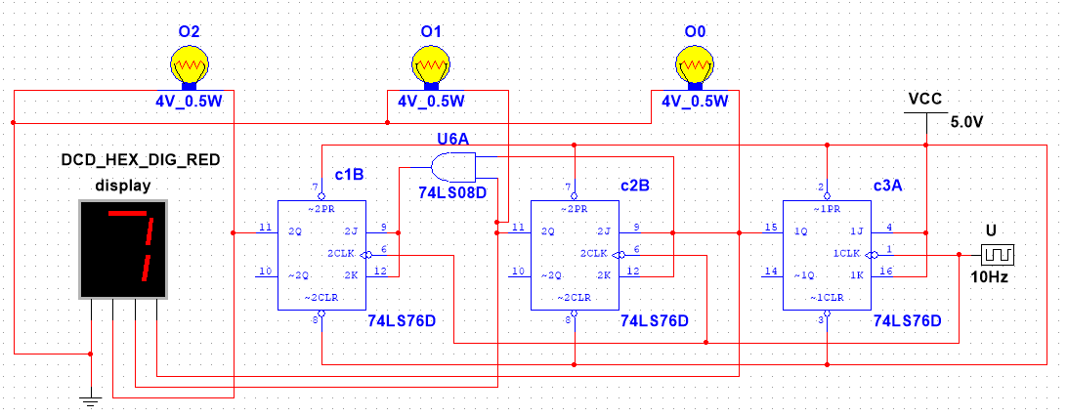

**3- bit asynchronous up counter:**

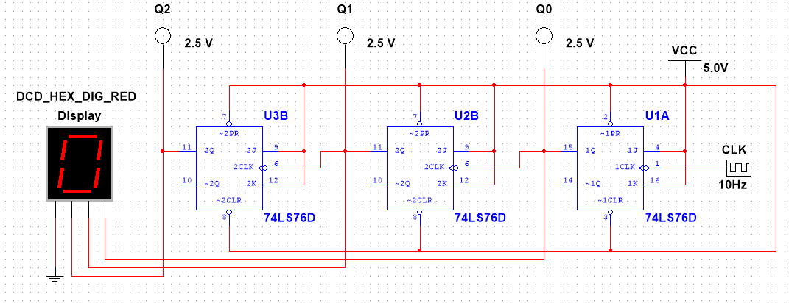

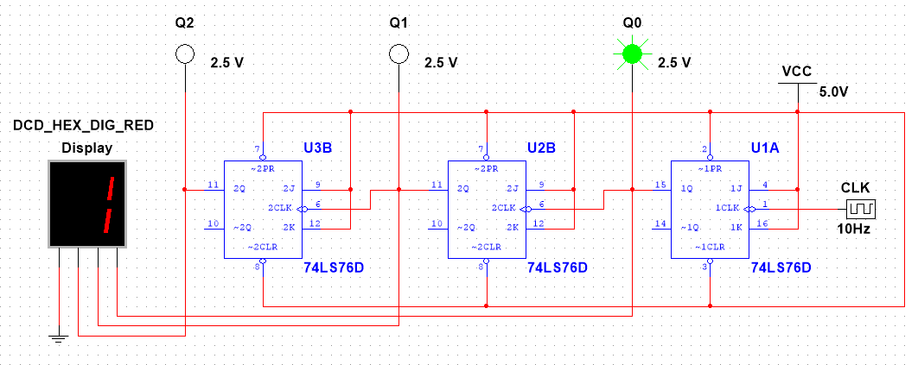

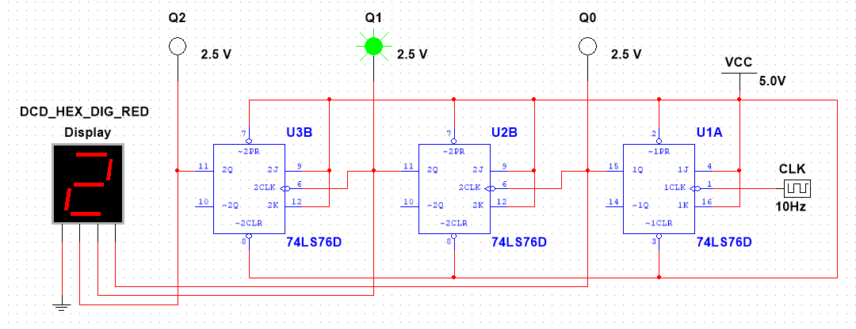

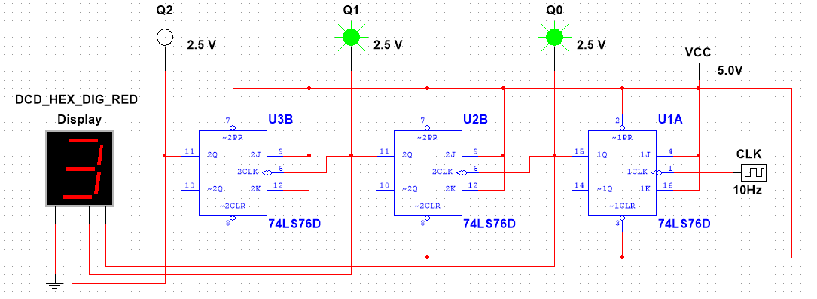

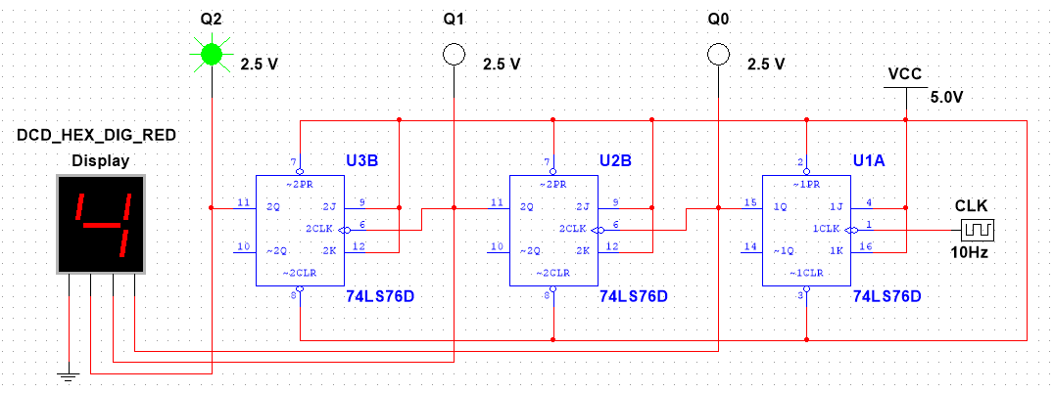

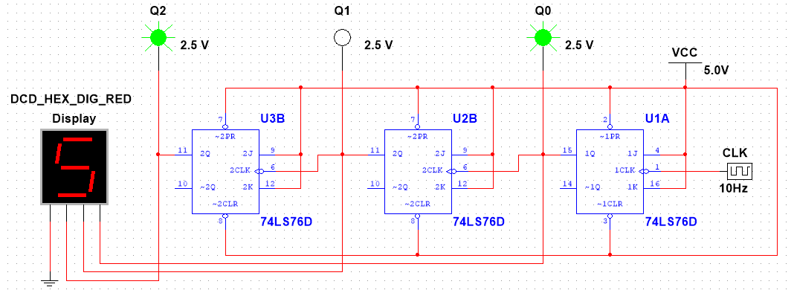

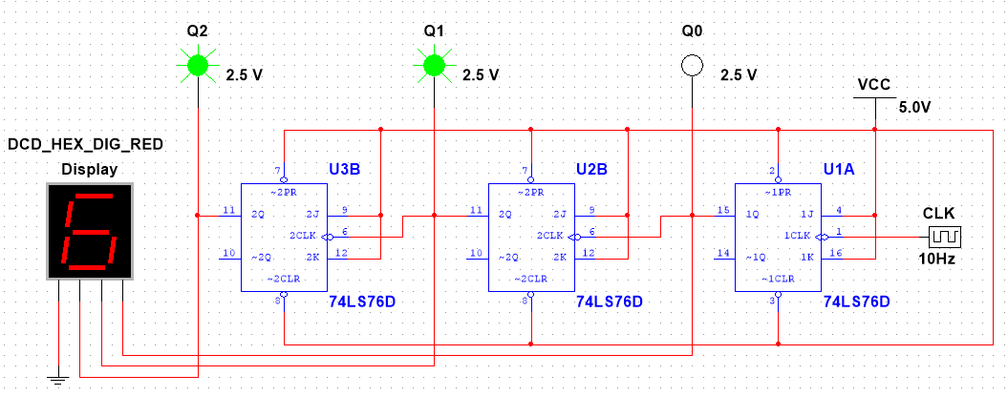

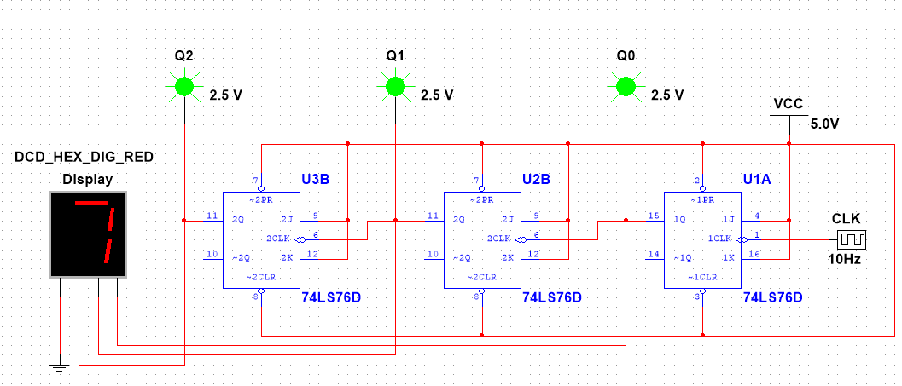

**4-bit Asynchronous Up Counter:**

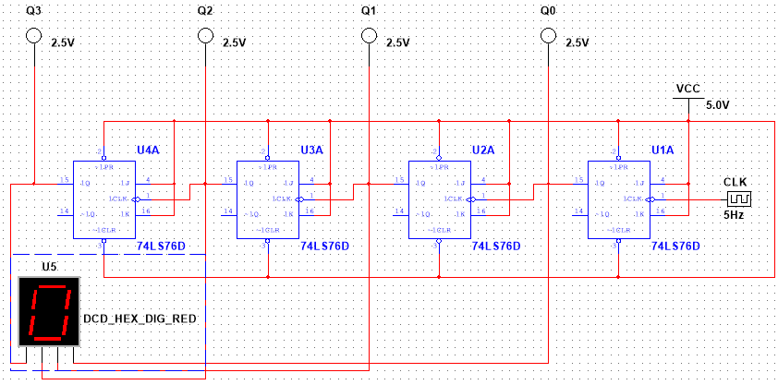

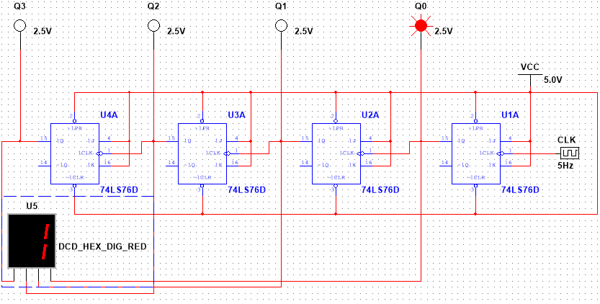

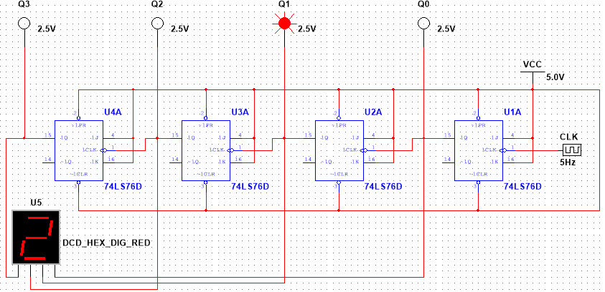

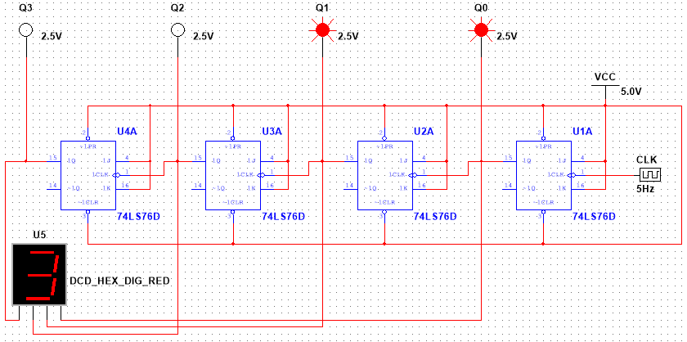

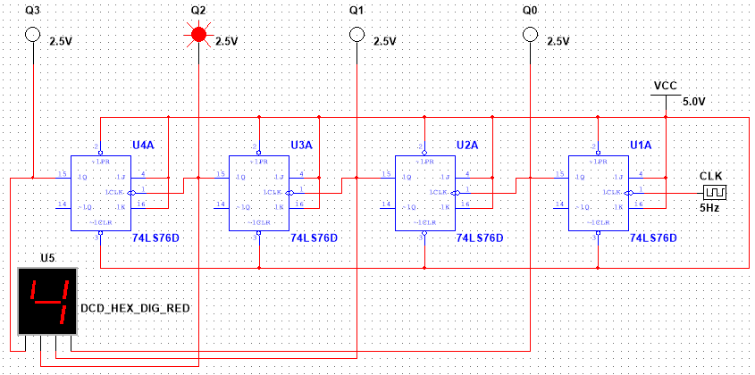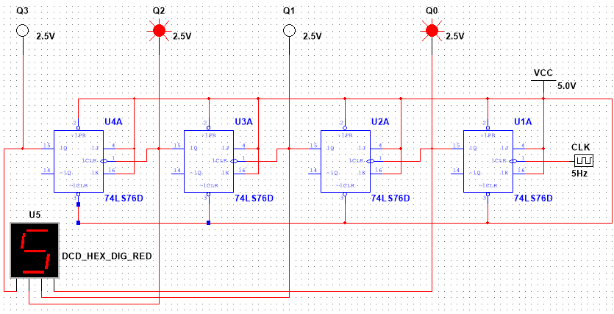

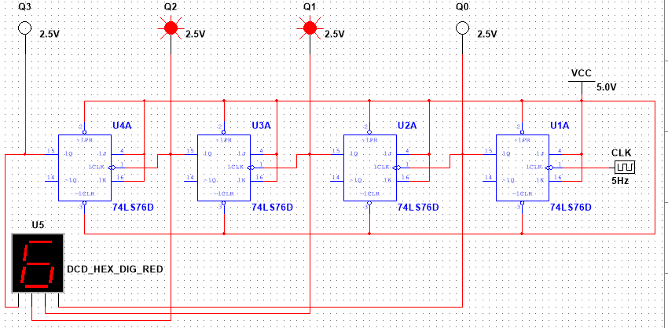

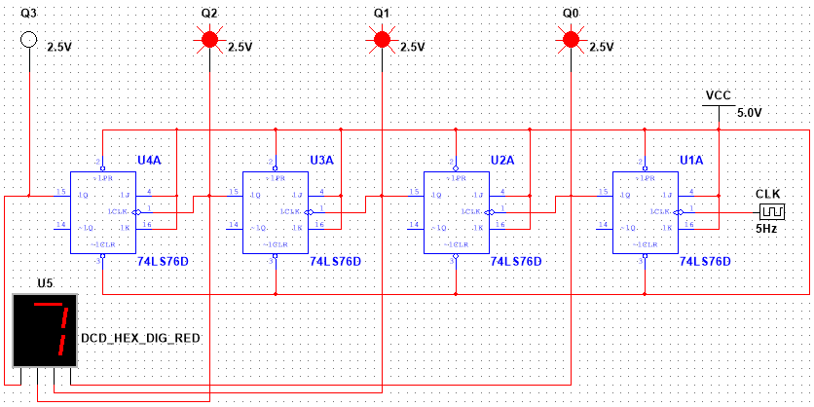

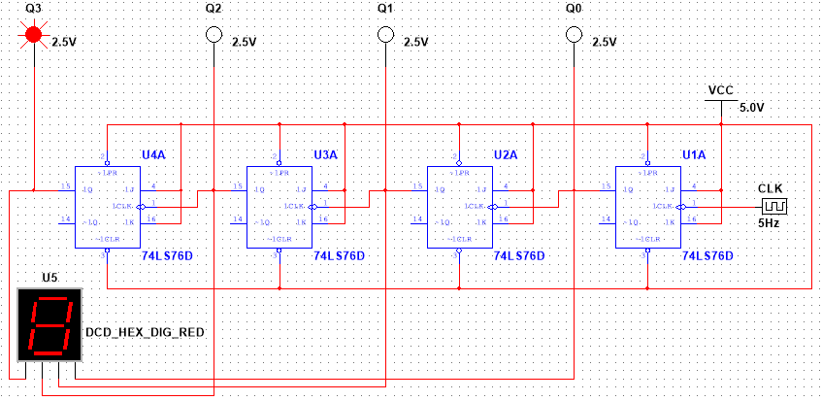

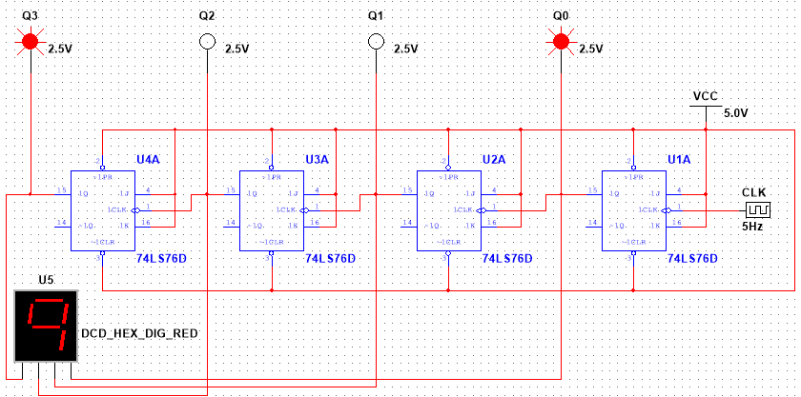

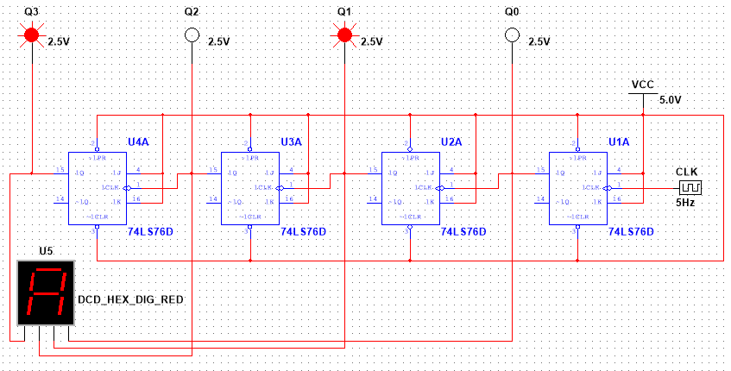

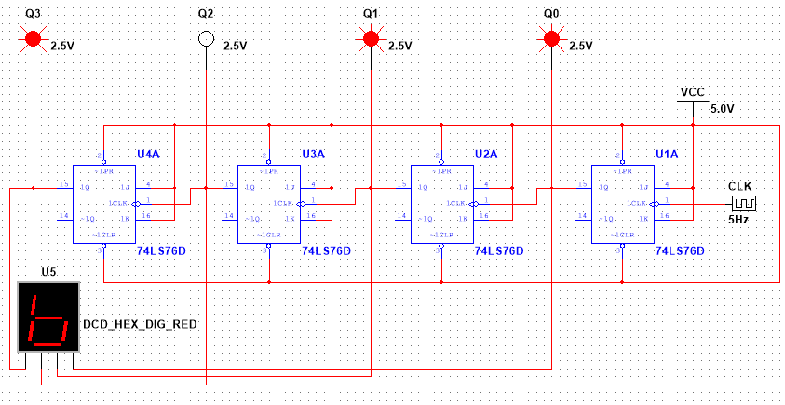

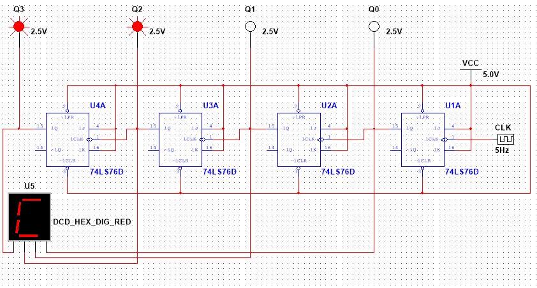

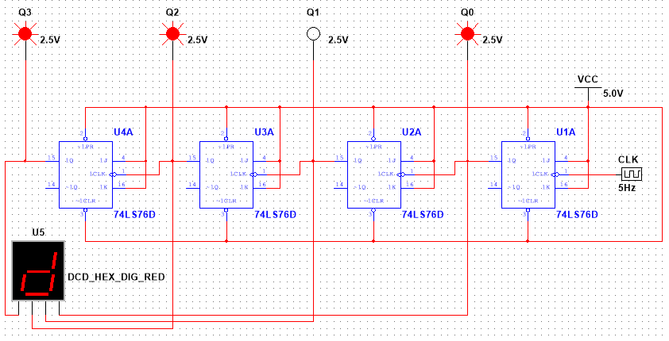

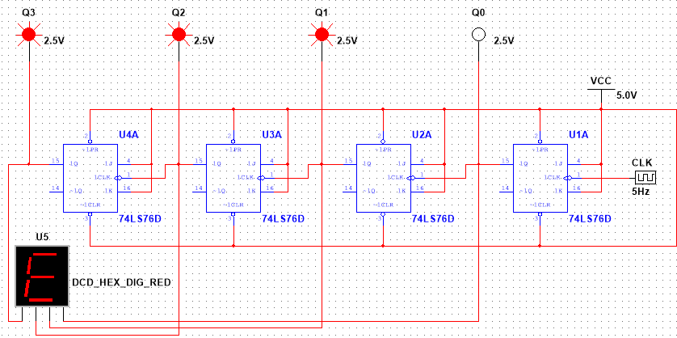

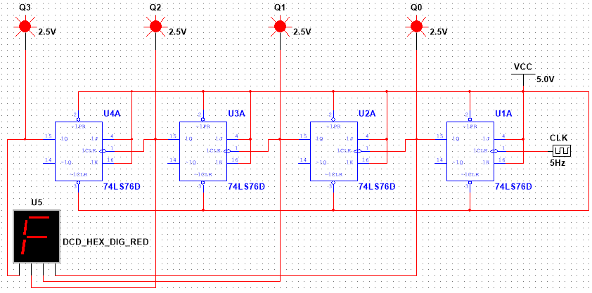

**4-bit Synchronous Up Counter:**

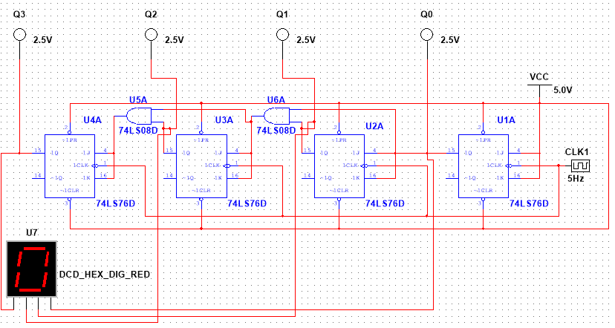

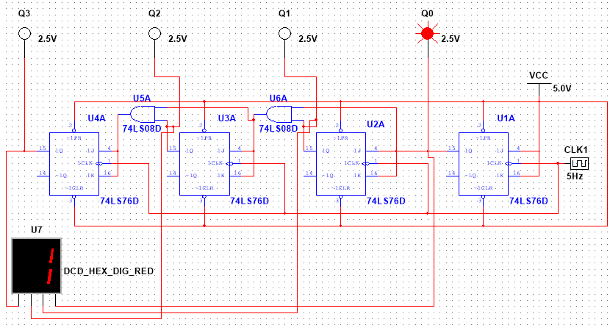

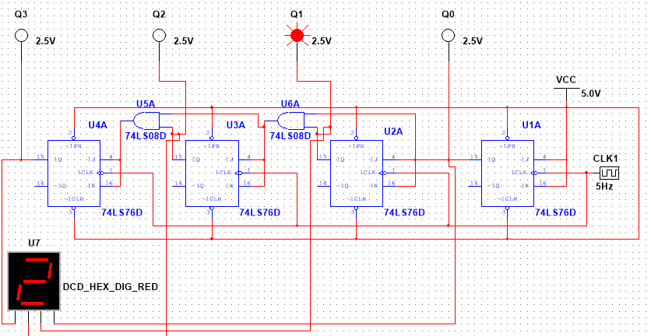

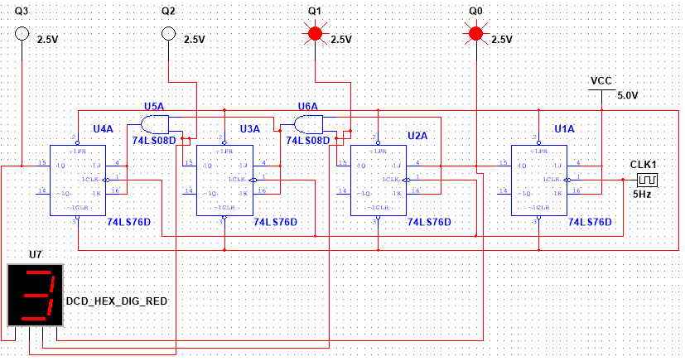

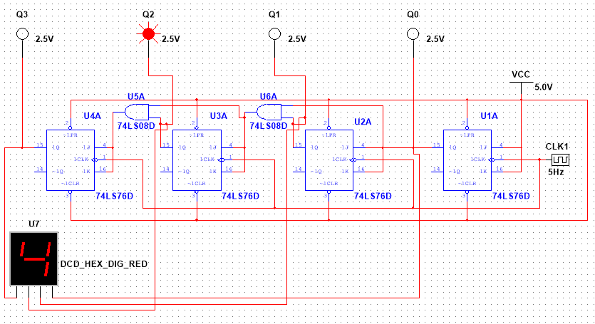

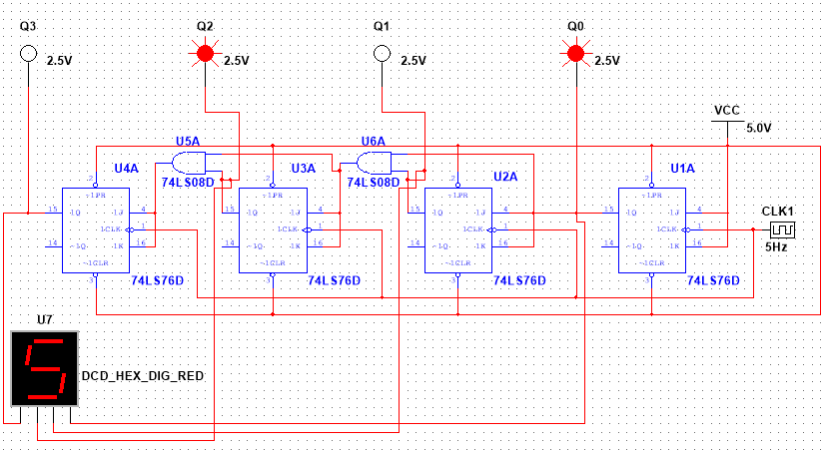

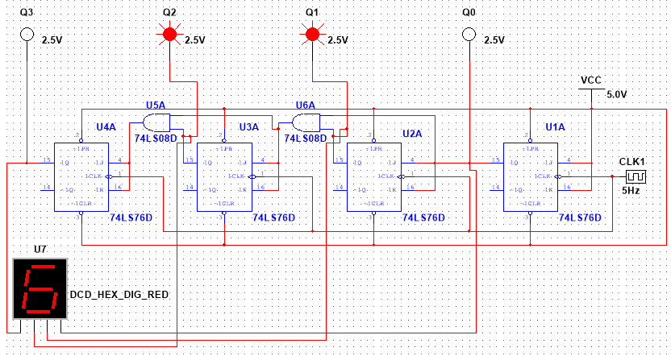

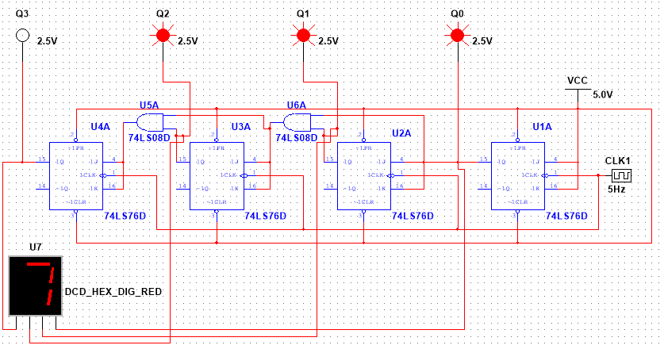

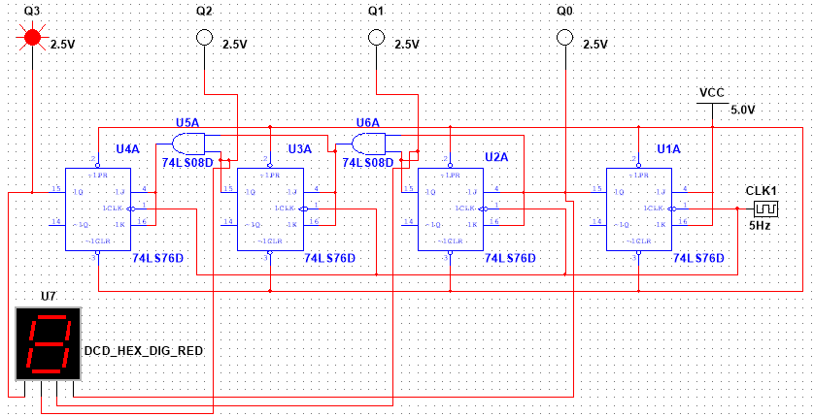

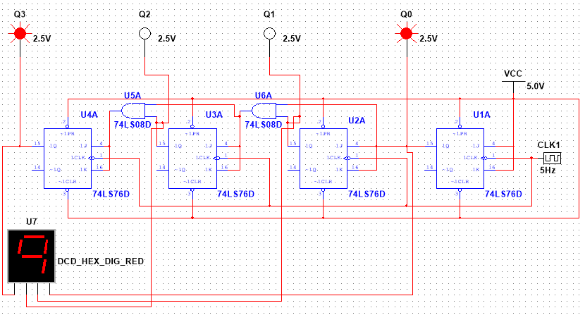

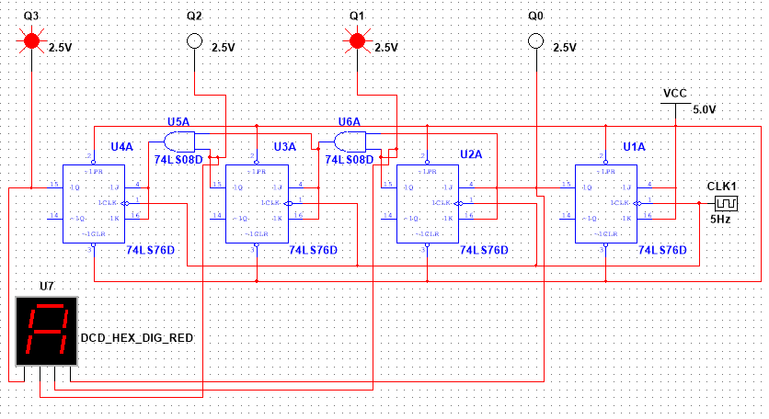

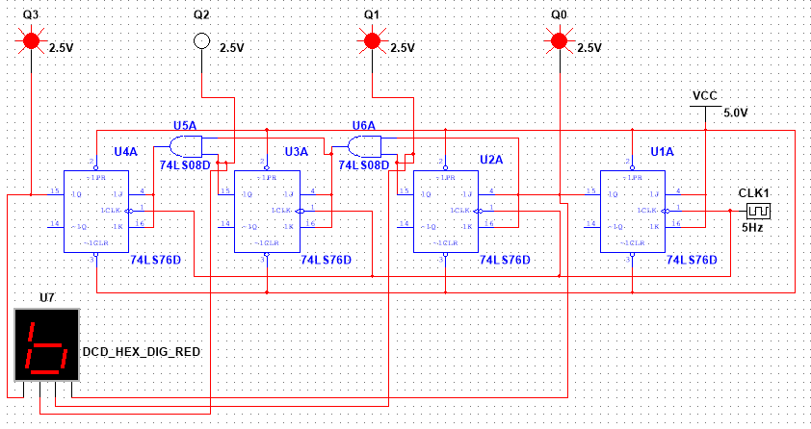

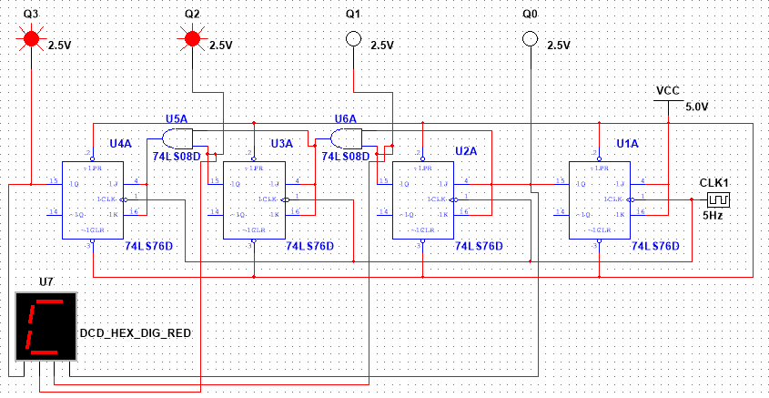

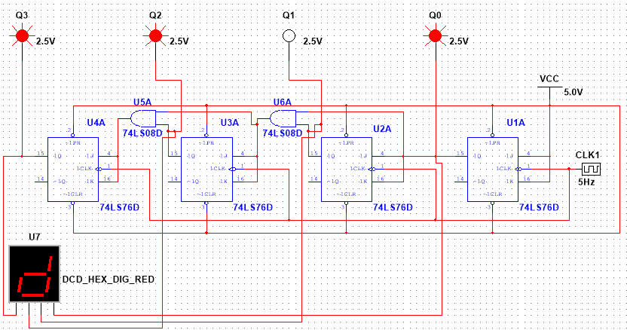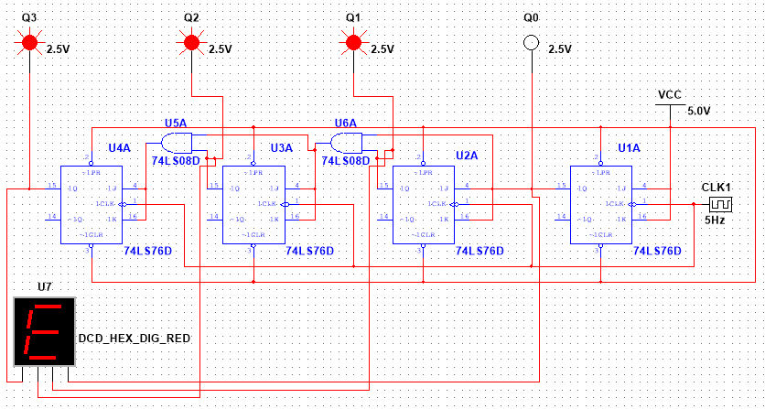

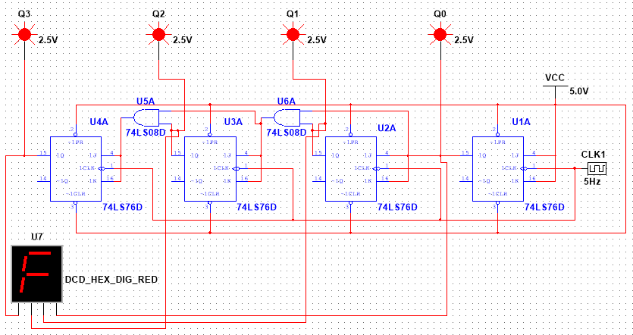

**3-bit Asynchronous down counter**

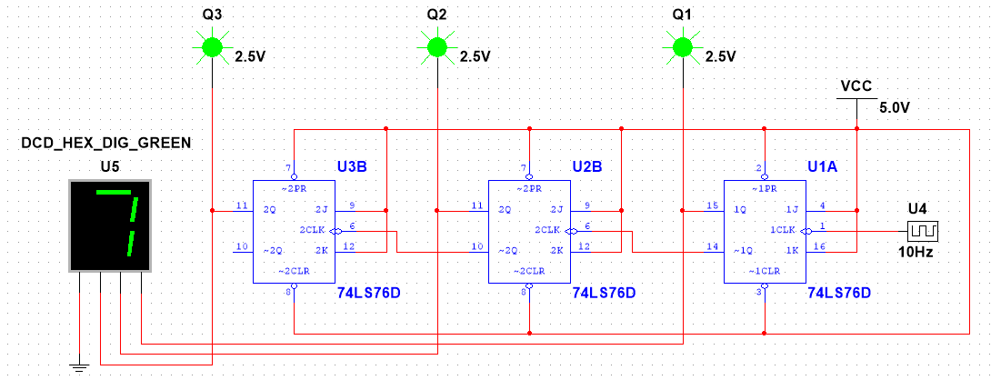

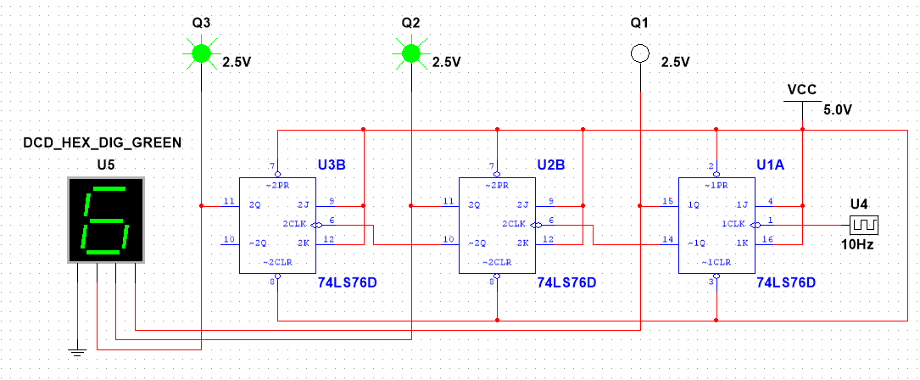

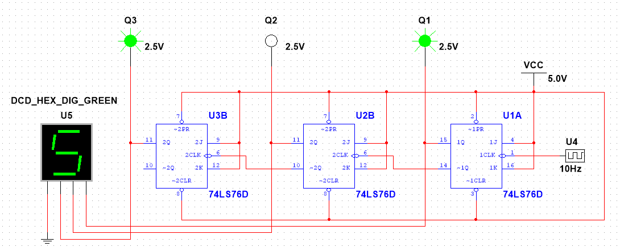

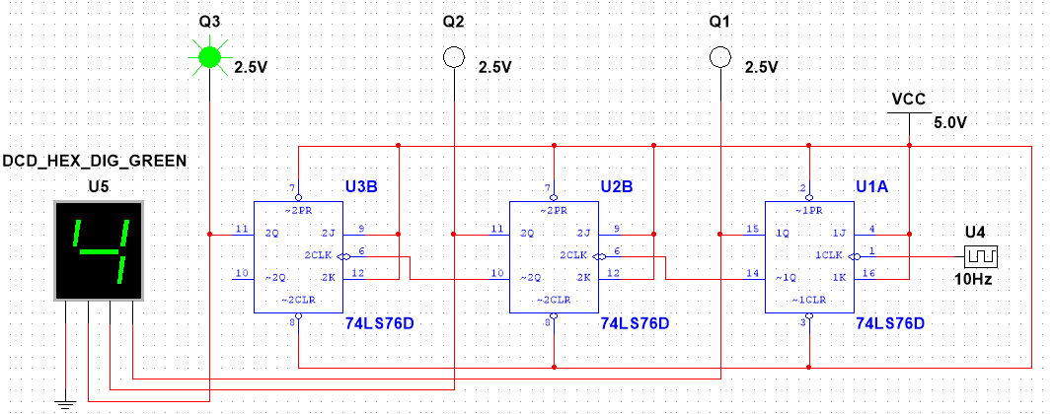

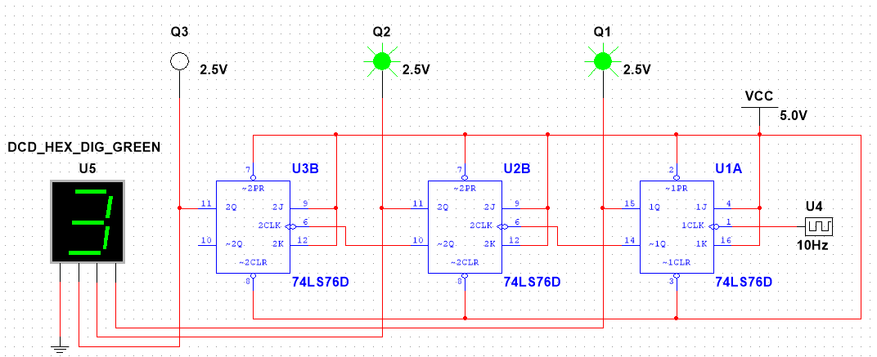

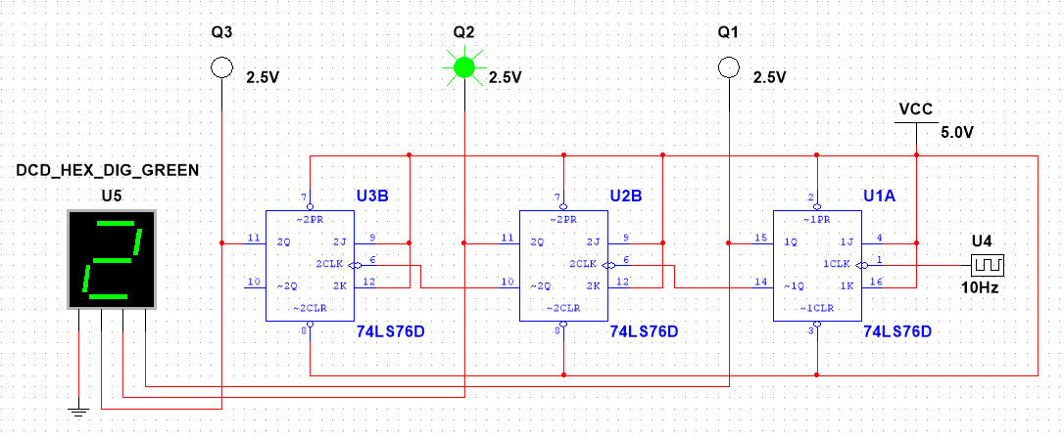

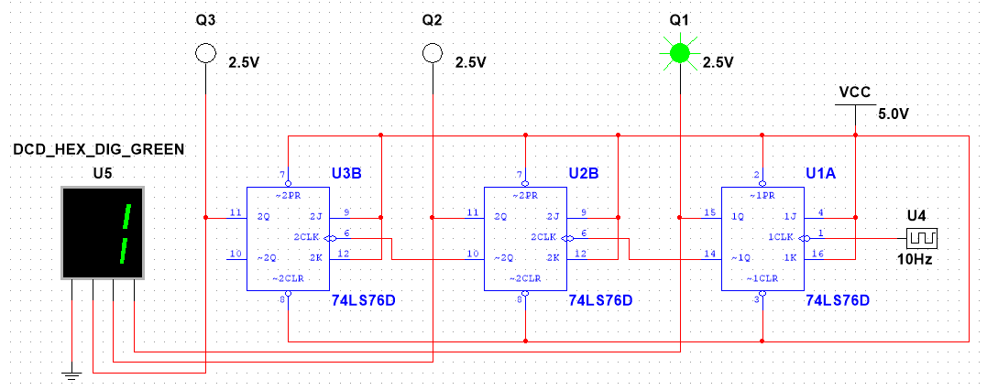

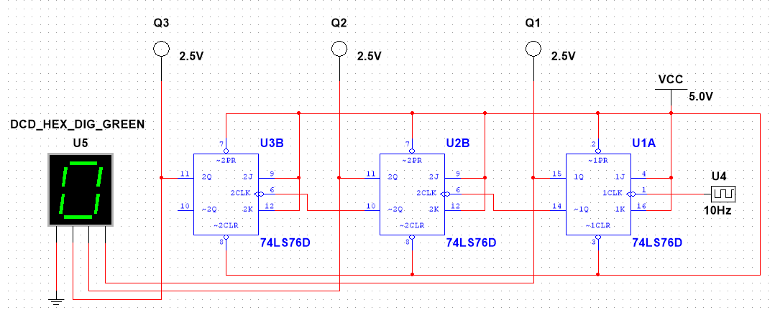

**Results:** The Simulation results matched the hardware implementation.

**Discussion:**

The experiment involved two parts: Asynchronous and Synchronous counters using a trainer board and JK Flip Flop IC. Initially, the Asynchronous counter used an external clock for the first flip-flop and cascaded outputs for subsequent ones, making it slower but simple. In contrast, the Synchronous counter employed a universal clock, allowing simultaneous flip-flop operation for higher speed, albeit with a more complex circuit. Designing and implementing 3-bit versions of both counters provided valuable insights into their processes and circuits.

**Reference:**

1. Thomas L. Floyd, “Digital Fundamentals,” available Edition, Prentice Hall International Inc.